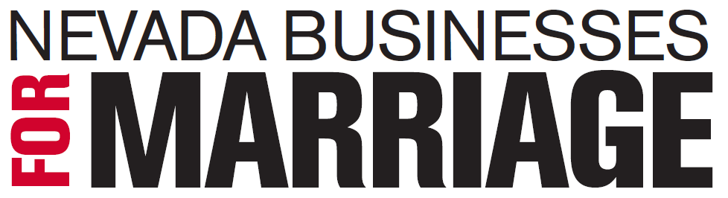

An Open Letter from Nevada Business Leaders on Marriage Equality

Many factors go into creating a state’s business environment. Perhaps most important is a state’s ability to attract top talent from around the world. Since human capital drives innovation and growth, a state must foster an environment where people want to live.

To be competitive, a state must create an equitable, fair and respectful environment for all of its citizens. For this reason – among others — it is vitally important that Nevada lawmakers enact marriage equality soon.

Marriage equality would strengthen the workforces of Nevada employers, who know there is no substitute for employees with diverse backgrounds and experiences. Companies must understand a changing marketplace and be able to connect with their customers; having a diverse workforce is a part of that. That’s one reason many employers have adopted non-discrimination policies and offer domestic partner benefits.

Marriage equality promotes economic development, too. As an example, New York City has generated $275 million in economic benefits plus city revenues directly linked to New York State’s decision to pass marriage equality in 2011 according to the office of the Mayor of New York City.

The American people are increasingly supportive of marriage equality, with a majority – 58% – believing same-sex couples should be allowed to marry. We agree with them. States with the metro areas of New York City, Seattle, Boston, and Baltimore have already legalized marriage equality. Nevada simply cannot afford to be less competitive than other states.

The Nevada legislature should act now. It’s the pro-jobs, pro-growth thing to do. It’s the right thing for Nevada.

Signed*,

Hugh Anderson
Caesars Entertainment
Robin and Danny Greenspun
Jan Jones
MGM Resorts International
Josh Miller
Monte Miller
Thom Reilly
Sig Rogich
Billy Vassiliadis
Wynn Resorts
Elaine Wynn

*Individuals listed as signatories represent themselves, only

