June 3, 2013

Unambiguous Support for Nevada Background Checks Legislation

To: | Interested Parties
From: | Greenberg Quinlan Rosner Research  Americans for Responsible Solutions

As background checks have been so far unable to break the political gridlock in Washington, the states have moved forward, passing legislation to reduce gun violence in Colorado and are proposing a similar ballot measure in Washington. A recent proposal for background checks in Nevada shows this state is also ready to move forward with common sense legislation.

An unambiguous 72 percent support Senate Bill 221 requiring background checks on most private sales and transfers of guns, including those sold on the Internet and at gun shows. This majority includes 85 percent of Democrats and 64 percent of Republicans, as well as 76 percent of gun owners and even 55 percent of NRA households. Intensity clearly stands on one side, as 48 percent strongly support this legislation and just 16 percent strongly oppose.

Figure 1 – Support for Background Checks
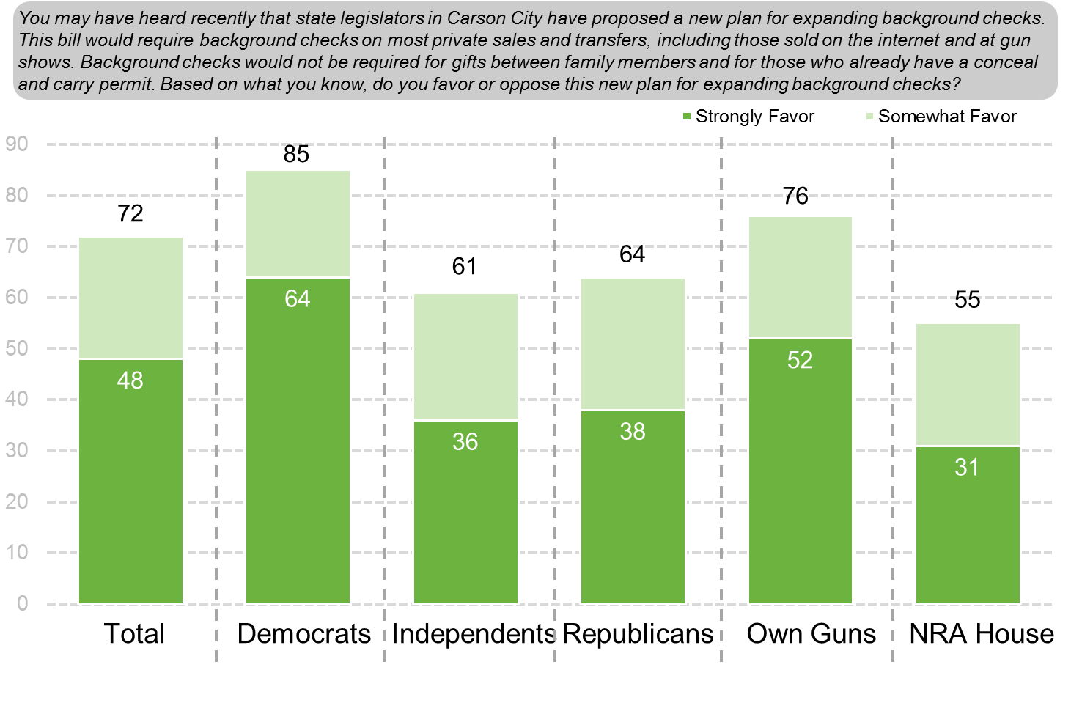
This issue carries some electoral bite as well. Sandoval is one of the more popular Governors in the country. Nonetheless, a 39 percent plurality, including 34 percent of independent voters, describe themselves as less likely to support him if he vetoes this legislation. Just 22 percent are more likely.

Survey Methodology

These are findings from a phone survey of 600 registered voters conducted May 29-June 2, 2013. Respondents were reached both by landline and cell phone. The sample for this survey was drawn randomly from a list of registered voters and stratified by county. Quotas were assigned to reflect the population of registered voters in each county. The sample also reflects the demographic composition of registered voters. Thirty-six percent (36 percent) of the interviewing was conducted using cell phones. The margin of error is +/- 4 percentage points at the 95 percent confidence level.

According to the survey, 84 percent support the policy of background checks on all gun sales, including those sold on the internet and at gun shows, mirroring recent polling.

